Contact: Maria Le @ 408.795.1859 FOR IMMEDIATE RELEASE
email :lunapark_chalkfestival@yahoo.com

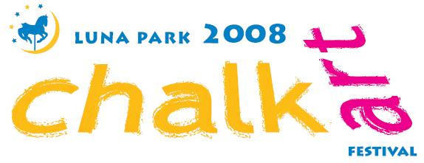
Celebrating the Northside’s Italian heritage • Fostering community pride and creative expression in the spirit of the Mexican and Chicano mural movements

Artists only may begin works Friday, October 3, 2008 9:00–5:00 p.m.
Public event: Saturday, October 4, 2008 9:00 a.m.–3:00 p.m.
Backesto Park
13th & Jackson streets, San Jose
Food Drink Music Bocce Ball

FEATURED CHALK ARTISTS
Wayne & Cheryl Renshaw Katrina Loera &student team
8-year veterans of chalk art Creator, Backesto Park mural
festivals throughout California
free admission
2’x2’ chalk space, box of chalk $10 day of event

Potential sponsors or artists interested in creating a larger work: download forms at www.lunaparkbusiness.com
Artists who find their own sponsors receive 10% of sponsorship amount. We will also link you with a sponsor on a first-come, first-served basis if you submit an example of your work as specified on the artists’ form. All other participating artists without sponsors will receive a share of 10% of total sponsorships not tied to an artist. Lunch provided 10/4/08.

Net proceeds benefit arts education in Northside neighborhood schools

Come celebrate the Italian tradition of chalk art! • Recreate a famous artwork or create an ephemeral pavement mural of your own • Sponsor an artist and advertise your business • Stroll the Sidewalk Art Gallery • Savor Chiaramonte’s famous Italian sausages and Giovanni’s pizza •Sip an icy Italian soda • Learn the basics of bocce ball • Relax under the trees, serenaded by strolling musicians • Let your kids create an impromptu masterpiece on Percorso dei Bambini.

Media photo/interview opportunity w/artists: Friday, Oct. 3, 2008 5:00 p.m.
View the Renshaw’s gallery at http://www.wr-architect.com/imad/index.html

Sponsored by the Luna Park Business Association
We strive to improve the business climate for all entrepreneurs working in the Northside neighborhood of San Jose and to create a positive identity for the area

